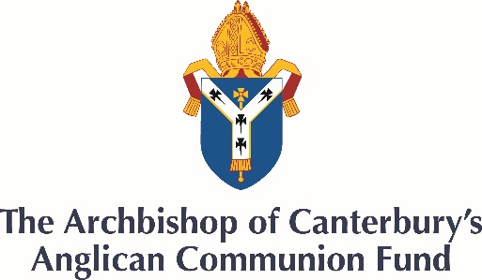

Together In Unity Appeal
Fundraising Resources for Dioceses and Parishes
Thank you for supporting the Together in Unity Appeal. The following resources are provided to enable you to share information about the appeal and also provide details of how to submit your donation.
- Ways to give and Gift Aid
- Articles for Church bulletins/newsletters and announcements
- Powerpoint slides about the Appeal
- Video message
- Further Information
Ways to give
- Online donations can be made at: give.net/Together_In_Unity

- To donate via BACS please give to: Friends of ACF / Account no. 00030397 / Sort code 40-52-40

- For donations from outside of the UK, please use:
IBAN: GB64CAFB40524000030397 / Swift/Bic: MIDLGB22XXX
For Diocesan fundraising:
In order for the ACF to attribute online donations to a particular diocese, donors can include the name of their Diocese in the message box at the point of donation. If a diocesan representative can get in touch with the ACF directly by filling out the form on the appeal webpage.
Gift Aid
Within the UK, UK taxpayers can increase the value of their donation by 25% with no additional cost by declaring Gift Aid. This can be automatically selected on the give.net website.

Articles for Church Bulletins/newsletters and Announcements
100 words
The Together in Unity Appeal
“Behold, how good and pleasant it is when brothers dwell together in unity.” Psalm 133:1
The COVID-19 pandemic has hurt communities throughout the world. Many communities are not equipped with even the most basic of hygiene and sanitation facilities, and lockdown measures have increased economic hardship in the poorest communities with people unable to work. The Archbishop of Canterbury has launched the Together in Unity Appeal, based on Psalm 133:1, to raise funds to support virus prevention and emergency relief for vulnerable communities throughout our Anglican family. Find out more and give at: archbishopofcanterbury.org/appeal
200 words
The Together in Unity Appeal
“Behold, how good and pleasant it is when brothers dwell together in unity.” Psalm 133:1
The COVID-19 pandemic has hurt communities throughout the world. Many communities are not equipped with even the most basic of hygiene and sanitation facilities, and lockdown measures have increased economic hardship in the poorest communities with people unable to work. The Archbishop of Canterbury’s Together in Unity Appeal is raising funds to support virus prevention and emergency relief for vulnerable communities throughout our Anglican family.
The Anglican Communion Fund has already begun responding to COVID related needs, allocating over £180,000 across 21 provinces of the Communion. We are supporting the Church in its ministry, providing food relief to the vulnerable, communicating ways of staying safe from the virus, and providing handwashing facilities and PPE. In the South Sudanese Diocese of Maridi, an ACF grant provided food items, soaps and seeds to over 200 pastors and lay-readers and provided bicycles and hand microphones for pastors to carry prevention messages into remote areas. Speaking of the support, Bishop Moses Zungo said, “You held our hand during our most trying moments.”
To find out more and to give to the appeal, please visit: archbishopofcanterbury.org/appeal

PowerPoint Slides
A small collection of PowerPoint slides that can be used in online church services or announcements can be found on the website at: https://www.archbishopofcanterbury.org/about/together-unity-appeal-fundraising-resources.

Video message
A video message about the Together in Unity appeal from Archbishop Justin Welby featuring images of the impact of COVID-19 across the Anglicans Communion and the testimonies of two Anglican primates. https://youtu.be/5U2i_bMCneM

Further Information
For further information, please submit contact details online on the appeal webpage or email ACF@lambethpalace.org.uk.

